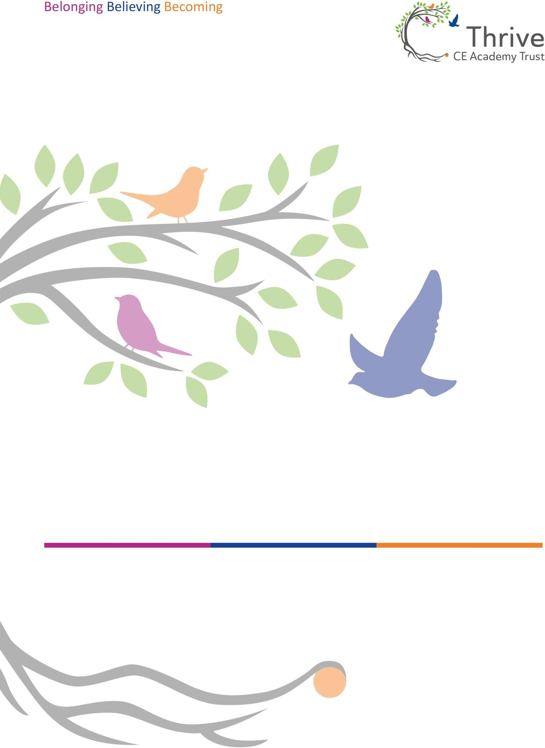

EYFS Curriculum Policy 2025-26



Introduction
This policy outlines the purpose, nature and management of the Early Years Foundation Stage (EYFS) across Thrive CE Academy Trust to all its pupils aged three to five years. We value the importance of the EYFS in providing a secure foundation for future learning and development.
The implementation of this policy is the responsibility of practitioners working in the individual Schools’ EYFS settings, including both teaching and non-teaching staff. In the policy, the term ‘setting’ refers to the Early Years educational provision within each of the Thrive Schools. The term ‘practitioner’ refers to all members of staff working with children within the setting.

Aims
This document is a principled approach to Early Years education, bringing together children’s welfare, learning and development requirements through four overarching principles:
  - Every child is a unique child, who is constantly learning and can be resilient, capable, confident and self-assured.
  - Children learn to be strong and independent through positive relationships.
  - Children learn and develop well in enabling environments, in which their experiences respond to their individual needs and there is a strong partnership between practitioners and parents and/or carers; and
  - Children develop and learn in different ways and at different rates.

Legislation
From September 2025, the EYFS statutory framework introduces strengthened requirements to ensure children’s safety, health, and learning.
  - All settings must have a Paediatric First Aid-trained member of staff present at all times, including during meals and outings, and maintain up-to-date certificates.
  - Providers must implement safe eating practices, including allergy checks, supervision during meals, and food preparation to reduce choking risks, alongside following the statutory EYFS Nutrition Guidance.
  - Safeguarding measures have been enhanced with stricter recruitment checks, whistleblowing procedures, and attendance monitoring.
  - Planning must reflect the Characteristics of Effective Teaching and Learning, and Reception Baseline Assessments remain mandatory within the first six weeks.
These changes aim to promote high-quality provision and robust safeguarding across all early year's settings.

Statutory Framework for The Early Years Foundation Stage
Although academies will take an individual approach, EYFS teaching in each setting is delivered in accordance with the Department for Education’s Early Years Foundation Stage Statutory Framework, July 2025.
All EYFS settings within Thrive CE Academy Trust strive to provide:
  - Quality and consistency in all Early Years settings, so that every child makes good progress, and no child gets left behind.
  - A secure foundation through learning and development opportunities which are planned around the needs and interests of each individual child and are assessed and reviewed regularly.
  - Partnership working between practitioners and parents and/or carers.
  - Equality of opportunity and anti-discriminatory practice, ensuring that every child is included and supported.

Areas of Learning & Development
There are seven areas of learning and development that must provide a framework for planning, teaching, and assessing in early years' settings (Early Education, 2012). All areas of learning and development are interconnected.

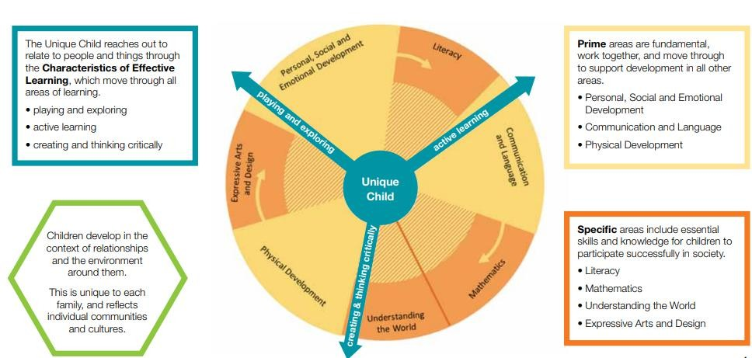

The three prime areas are:

  - Communication and Language – our children are given lots of opportunities to experience a rich language environment; to develop their confidence and skills in expressing themselves; to speak and listen in a range of situations.
  - Physical Development – our children are provided with opportunities to be active and interactive; to develop their co-ordination, control and movement. Children are taught the importance of physical activity and to make healthy choices in relation to food.
  - Personal, Social and Emotional Development – our children develop a positive sense of themselves and others; forming positive relationships and develop respect for others; develop social skills and learn how to manage their feelings; understand appropriate behaviour in groups; and have confidence in their own abilities. (Early Education, 2012)

There are also four specific areas, through which the three prime areas are strengthened and applied:
  - Literacy – our children are taught to link sounds and letters and to begin to read and write. Children are given access to a wide range of reading materials to ignite their interest and passion for reading.
  - Mathematics – our children are provided with opportunities to develop and improve their skills in counting, understanding and using numbers, calculating simple addition and subtraction problems; and describing shapes, spaces and measures.
  - Understanding the World – our children make sense of their physical world and their community through opportunities to explore, observe and find out about people, places, technology and the environment.
  - Expressive Arts and Design – our children explore and play with a range of media and materials, as well as sharing their thoughts, ideas and feelings through a variety of activities in art, music, movement, dance, role-play, and design and technology. (Early Education, 2012)

Our curriculum is planned through a booked based approach that reflects and responds to the children’s interests, offering experiences in all areas of the curriculum and which carry equal importance to provide a broad and balanced curriculum with opportunities for play and child-initiated activities.

Characteristics of Effective Teaching & Learning

In planning and guiding children’s activities, practitioners will reflect on the different ways that children learn and reflect these in their practice. Children are encouraged to be independent, and we have many areas and activities where children can self-select materials and equipment. Through such child- initiated play the children can develop ‘Characteristics of Effective Teaching and Learning’ which are:
  - playing and exploring - children investigate and experience things, and ‘having a go’;
  - active learning - children concentrate and keep on trying if they encounter difficulties, and enjoy achievements;
  - creating and thinking critically - children have and develop their own ideas, make links.
Quality learning experience for children requires a quality workforce. Thrive CE Academy Trust will endeavour to ensure every setting has a well-qualified, skilled staff.
The level of progress children should be expected to have attained by the end of the EYFS is defined by the early learning goals as set out in the statutory framework.

Thrive CE Academy Trust Curriculum

Rationale
We have carefully mapped out the progression of skills and knowledge through Early Years which informs our planning and allows us to monitor children’s needs and stages of development. This document also flows into our Trust-wide progression maps for Key Stage 1.

Planning
Planning within Thrive CE Academy Trust is a collaborative process, bringing together Early Years teachers across the Trust to share expertise and specialisms. This approach ensures a high-quality curriculum that is closely aligned with the Nursery and Reception progression maps, with the ultimate aim of supporting all children to achieve the Early Learning Goals by the end of Reception.
Our planning focuses on providing relevant, engaging activities and experiences that reflect the skills children are developing. Practitioners consider the different ways children learn and incorporate opportunities to foster the Characteristics of Effective Teaching and Learning into daily practice.
Where a child has a special educational need or disability (SEND), staff carefully assess whether additional or specialist support is required. This includes working closely with the school SENCO and, where appropriate, liaising with external agencies to ensure every child receives the support they need to thrive.

Provision
Within Thrive CE Academy Trust, we believe that effective, continuous provision should provide children with the opportunity to demonstrate all characteristics of effective teaching and learning.
The continuous provision helps to continue the provision for learning. Provision is well organised so children can access and organise their learning.
Providing open-ended learning opportunities encourages the children to demonstrate aspects of playing and exploring and achieve in multiple areas of learning. If we want our children to be creative and curious learners, then we must provide an environment that appeals to them and encourages them to make their own choices independently, without too much adult interaction. Even with continuous provision, we believe that the adult’s role is essential.
  - Firstly, a high-quality environment must be provided consistently, to ensure that the children are being exposed to a variety of different resources.
  - Secondly, when the children engage with the resources and activities planned, it is important for adults

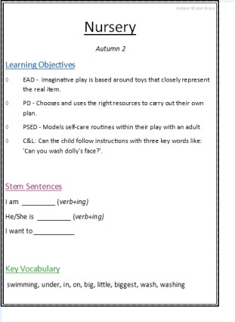
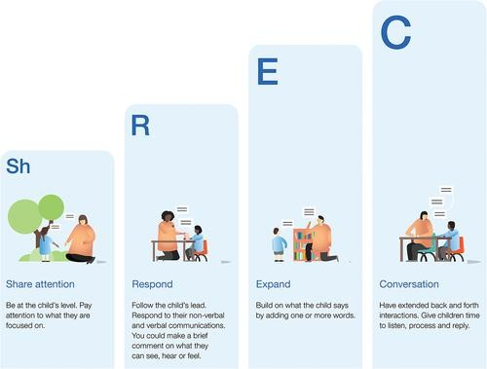
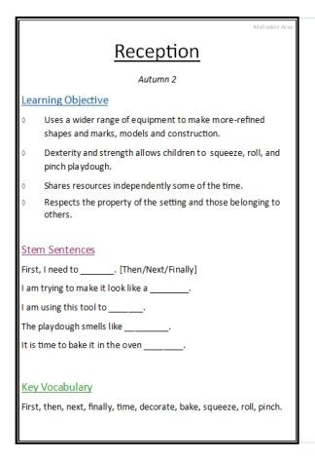
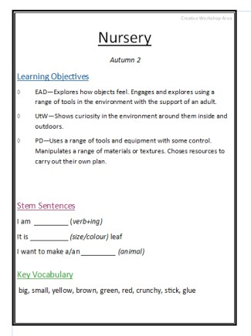
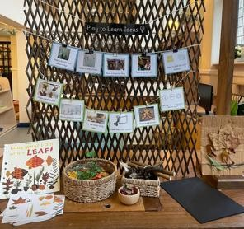
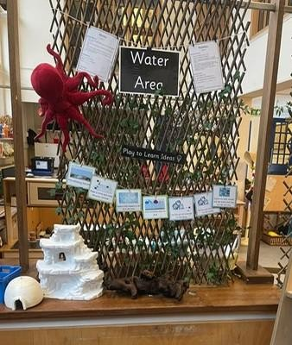
to make careful observations. Alongside providing an enriching environment, it is crucial for all adults to establish consistent, structured behavioural strategies so that the children understand what is expected of them.

Ways we ensure continuous provision is effective:

- High Quality interactions are a guiding principle: We use open-ended questions to engage the children in conversation and to prompt their creative thinking – these questions often begin with what or how.
  - We encourage children to take part in a back and forth conversation – ShREC approach:

  - Teaching children new vocabulary and using language
  - Extending and scaffolding children’s thinking and developing their independent learning.

- Within each provision area, Skill Signs are strategically placed to support high-quality adult-child interactions and purposeful learning. Practitioners working in these areas are equipped with a clear understanding of the intended learning outcomes, enabling them to scaffold children's thinking effectively. Through the use of carefully selected sentence stems and subject-specific vocabulary, staff promote oracy by modelling rich language, encouraging extended dialogue, and facilitating peer-to-peer conversations. This approach fosters language development, critical thinking, and collaborative learning, in line with the EYFS emphasis on communication and language as a prime area of learning.

- We provide children with time to revisit their prior learning on a daily basis to ensure their knowledge and understanding is being embedded.
- We offer a variety of high-quality resources to support the children’s skills, knowledge and understanding.

- We make sure that each area enables the provision to be ‘continuous’ to ensure that each child can play and explore in a variety of ways using our ‘Play to learn’ signage. By following these principles, the provision planned for all our children challenges their understanding and encourages them to question one another’s thinking whilst offering high quality learning opportunities.

Assessment
The EYFS framework sets the standards that all Early Years providers must meet to ensure that children learn and develop well and are kept healthy and safe. It promotes teaching and learning to ensure children’s ‘school readiness’ and gives children the broad range of knowledge and skills that provide the right foundation for good future progress through school and life (Early Years Foundation Stage Statutory Framework, September 2025).
Accurate assessment enables parents, carers and practitioners to identify children’s progress, understand their needs, and to plan activities and support. Within the EYFS framework there are two types of assessment; summative and formative. The EYFS Framework requires all Early Years providers to report to parents, and sometimes to the local authority, at certain points throughout their time within the Early Years Foundation Stage, as indicated below.

Assessment | Timing | Notes
Reception Baseline Assessment  (RBA) | First 6 weeks of Reception | Activity-based; informs KS1  readiness
Thrive Assessment Benchmark  document | Every term | Activity based and informs  characteristics of learning
EYFS Profile | By 30 June in Reception year | Judgement against 17 ELGs; shared  with parents and LA

Baseline Assessments in Nursery and Reception
During Autumn Term 1 (the first 6 weeks in our schools), Nursery children are observed in child-led activities across the EYFS Prime Areas, while Reception children are observed across all Early Years curriculum areas.

Focus child approach – Nursery
Each week a small number of children are chosen to be a focus child. During child-initiated learning time, adults will focus on these children to identify their progress/next steps and learning styles, to shape future planning. During each child’s focus week, quality interactions and learning experiences are reflected on and used to inform next steps. These next steps are also shared with parents via the setting’s online communication platform.

Reception Baseline Assessment (RBA)
Reception children complete the statutory DfE Reception Baseline Assessment within their first 6 weeks. This short, activity-based assessment evaluates early language, communication, literacy, and mathematics skills using practical resources and paired touchscreen devices—or verbal responses where appropriate.

Data Use & Teacher Feedback
RBA results are not scored or used to label or track individual pupils. Instead, teachers receive brief narrative statements to guide teaching in the first term. The anonymised data is only published at the end of Year 6 as a school-level progress measure

Thrive Assessment Benchmark Document
Thrive CE Academy Trust schools use a comprehensive benchmark document that outlines clear developmental milestones from Nursery through Reception. This document enables staff to monitor and track each child’s progress effectively, highlighting areas where additional support may be required. Following the initial baseline assessment, progress reviews are conducted three times throughout the academic year to ensure ongoing development and targeted intervention.

Reporting to parents
Parents receive an annual report that offers comments on their child’s progress in each area of learning and a short commentary on their child’s skills and abilities in relation to the three key characteristics of effective teaching and learning.

End of Nursery
At the end of their time in Nursery, parents will receive a written report against the Prime Areas of learning, characteristics, and next steps. This ensures that necessary information is passed onto the next setting to build on the child’s knowledge and understanding. Those children with additional needs will have a report based around their characteristics of learning alongside their most recent individual support plan/targets. There will also be meetings and discussions with Reception class teachers, SENCOs and Designated Safeguarding Leads (DSL) at primary schools, as appropriate.

End of Reception
At the end of the EYFS, staff complete the EYFS profile for each child. We meet the family to discuss their child’s progress, next steps and support when transitioning to Year 1. Children are assessed against the 17 early learning goals, indicating whether they are:
- Meeting expected levels of development
- Not yet reaching expected levels (‘emerging’)
The profile reflects ongoing observations and discussions with parents and/or carers and is shared with parents and/or carers for their child. It is also used as part of the transition conversations held with Year 1 teachers. The profile is moderated internally and in partnership with other local schools to ensure consistent assessment judgements.
EYFS profile data is submitted to the Local Authority.

Parents as Partners
At Thrive CE Academy Trust, we recognise the vital importance of building strong, positive relationships with parents and carers, as emphasised in the EYFS framework. Working in partnership with families is central to the Early Years Foundation Stage (EYFS). We value parents as a child’s first educators and understand the significant role they play in their child’s learning and development. Practitioners actively encourage parents to share their unique knowledge and insights, helping us to build a holistic picture of each child.

Engagement Before Starting School
Parental involvement begins before children join our academies. Families are invited to visit the school, meet their child’s teacher, and explore the classroom environment. Reception parents are welcomed in the summer term prior to their child starting school, where they receive essential information for the upcoming academic year. Staff also conduct home visits which are designed to build strong relationships with families, ease the transition into nursery, and gather valuable insights about each child’s home environment, routines, and interests. These visits create a sense of trust, help practitioners plan for individual needs, and reinforce the partnership between parents and educators, ensuring a smooth and supportive start to the child’s learning journey.

Ongoing Partnership
Throughout the year, we encourage families to contribute to their child’s learning journey by sharing achievements and progress from home. Our Trust operates an ‘open door’ policy, ensuring parents feel comfortable raising questions or concerns with their child’s teacher or key worker. Formal opportunities for feedback include parent consultations and a detailed end-of-year report, enabling practitioners to share progress and next steps. Schools also provide opportunities for parental involvement such as: Mystery reader, Harvesting Happy Memories, Information Evenings, Stay and Play sessions etc.

Safeguarding
Thrive CE Academy Trust requires all EYFS staff and leaders to rigorously follow the principles outlined in this policy and those in the EYFS Statutory Framework 2025. Safeguarding and welfare concerns will be managed in accordance with the Trust’s Safeguarding & Child Protection Policy, fully updated to reflect strengthened safeguarding expectations.
To ensure compliance:
  - All staff (including trainees and apprentices) must complete in-depth safeguarding training at least every two years, aligned with Annex C of the EYFS 2025 framework.
  - Staff also receive annual updates on policy changes at the start of each academic year and read both the EYFS framework and Trust safeguarding guidance during their induction. The EYFS Leader maintains and audits staff training records, including Paediatric First Aid certification and safer recruitment compliance, to ensure up-to-date professional standards.

Health, Safety and Welfare: Paediatric First Aid and Safe Eating Practices

Paediatric First Aid (PFA)

In line with statutory EYFS requirements, Thrive CE Academy Trust ensures:
  - All our members of staff who work in EYFS hold a valid Paediatric First Aid certificate. They are present during meals and snack times, and on all outings.
  - PFA training is renewed every three years, and compliance is monitored.
  - Newly qualified Level 2/3 practitioners must complete PFA training within three months of starting to be included in staff ratios.
  - All staff are familiar with emergency procedures and know the location of first aid equipment.

Safe Eating Practices

To safeguard children during mealtimes:
  - A PFA-trained staff member must be present whenever food is served.
  - Allergy and dietary information are collected before admission, shared with all staff, and reviewed regularly.
  - Designated staff (usually the child’s key person) check the suitability of food before serving.
  - Children are seated safely and supervised within sight and hearing while eating.
  - Food is prepared to minimise choking risks (e.g., grapes sliced lengthways, no whole nuts).

  - For children with swallowing difficulties, staff follow specialist guidance (e.g., IDDSI framework or Speech and Language Therapist recommendations).

Nutrition and Hygiene

  - Thrive CE Academy Trust follows the statutory EYFS Nutrition Guidance to provide balanced, healthy meals.
  - Hygiene standards are maintained at all times, including handwashing before and after eating.
  - Emergency action plans for allergies and dietary needs are in place and communicated to all staff.

Monitoring
It is the responsibility of the EYFS Leader and staff to implement and adhere to the principles set out in this policy, ensuring compliance with the EYFS Statutory Framework (effective September 2025). As part of the school’s monitoring schedule:
  - The Headteacher/Head of School, in collaboration with the EYFS Leader, will conduct regular monitoring visits across the EYFS setting to ensure practice aligns with statutory requirements.
  - Monitoring will focus on learning and development, assessment, safeguarding, and welfare, as required under Sections 1–3 of the EYFS Framework.
  - Personnel records, training certifications (e.g., Paediatric First Aid), and staff-to-child ratios will be reviewed to comply with strengthened expectations introduced in 2025.
Safeguarding procedures will be audited, including safer recruitment, whistleblowing protocols, and children's attendance monitoring, in line with updated Section 3 requirements. Reports and action plans from monitoring visits will form part of the academy-wide quality assurance process, reviewed termly by Governors.
Thrive CE Academy Trust is committed to continuous improvement in EYFS practices. Through joint monitoring by the Headteacher/Head of School and EYFS Leader, we ensure accountability, uphold statutory standards, and provide every child with a safe, high-quality early learning experience.

Equal Opportunities
All practitioners have a responsibility to maintain positive attitudes to diversity and difference, ensuring that inclusive practice is delivered in the EYFS setting. All children, irrespective of gender, ability, special educational need, ethnicity, culture or religion, and social circumstances have the opportunity to experience a challenging and enjoyable programme of learning and development within each EYFS setting across Thrive CE Academy Trust

