Theme | Autumn 1 - All About Me – What makes me unique? |  | Autumn 2 – Nursery Rhymes & Celebrations - What is a special time for me? | Spring 1 – People who help us – Who helps me at school? | Spring 2 – Vehicles – How do we travel? | Summer 1 – Life on the farm - What animals live on a farm? | Summer 2 – Changes – What made Nursery special?
Title & Author | 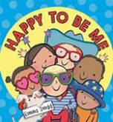  Happy to be me by Emma Dodd  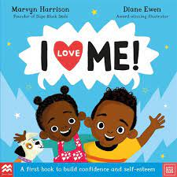  I love me by Maryn Harrison  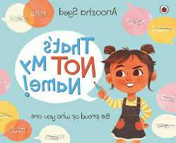  That’s not my name by Anoosha Syed |  | 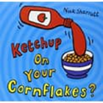  Ketchup on your cornflakes by Nick Sharratt  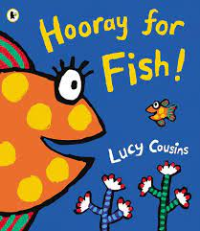  Hooray for Fish by Lucy Cousins  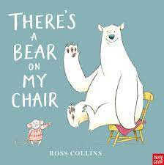  There’s a bear on my chair  by Ross Collins | 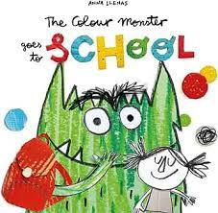  The Colour Monster goes to school by Anna Llenas  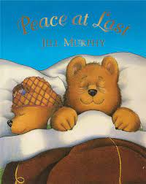  Peace at last by Jill Murphy  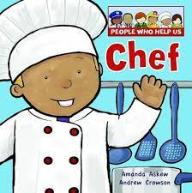  Chef – People who help us by Amanda Askew | 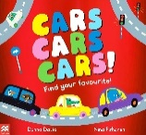  Cars, Cars, Cars by Donna David  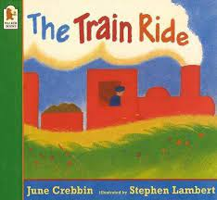  The Train Ride by June Crebbin  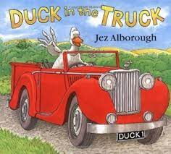  Duck in the truck by Jez Alborough | 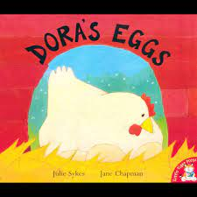  Dora’s Eggs by Julie Sykes  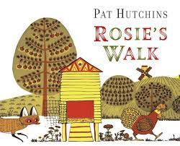  Rosie’s Walk by Pat Hutchins  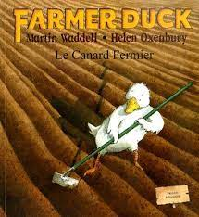  Farmer Duck by Jez Alborough | 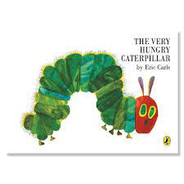  The Very Hungry Caterpillar by Eric Carle  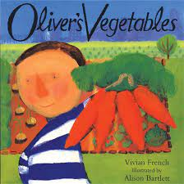  Oliver’s Vegetables by Vivian French  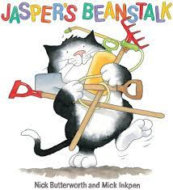  Jasper’s Beanstalk by Nick Butterworth
Poetry/  Rhyming Book focus | – Goat goes to Playgroup by Julia Donaldson |  | We’re going on a bear hunt by Michael Rosen | Miss Polly had a dolly by Alison Hawes | Dig, dig, digging by Margaret Mayo & Alex Ayliffe | Flip Flap Farm by Axel Scheffler | Down by the cool of the pool by Tony Mitton
Action Songs/  rhymes to know | * If You Are Happy and You Know It  * Head, Shoulders, Knees and Toes  * Humpty dumpty  • Baa baa black sheep  • Twinkle, twinkle, little star  • Row, row, row your boat  - Ten in the bed  - Are You Sleeping – Frere Jacques |  | - Five Little Leaves  - Rain, Rain, go Away  - I Hear Thunder  - What’s the weather?  - Wind the bobbin up  - One finger one thumb  - We’re going on a bear hunt  - Hot cross buns | - Miss Polly had a dolly  - Hokey cokey  - Nicky nacky nocky noo  - BINGO  - Down in the jungle  - Pat-a-cake  - This little piggy went to market  - Jack and Jill  - The Grand old duke of York | - Wheels on the bus  - Row row row your boat  - A Sailor Went to Sea  - The Big Ship  - Tommy thumb | - Dingle Dangle Scarecrow  - Hey diddle diddle  - Baa baa woolly sheep  - Little Peter Rabbit had a fly upon  - 5 little ducks  - Old McDonald had a farm  - The farmers in his den | - Incy Wincy Spider  - There’s a tiny caterpillar on a leaf wiggle, wiggle.  - There’s a worm at the bottom of the garden.  - Mary, Mary quite contrary  - There was an old lady
Linked texts to read at storytime | - Guess how much I love you  - Socks  - Lulu’s first day  - Dear Zoo  - Can’t you sleep little bear? |  | - The Best Diwali  - Hairy Maclary  - Brown Bear, Brown Bear What do you see?  - Owl Babies  - Meg & Mog | - Something beginning with Blue  - It’s okay to be different  - Elmer  - Giraffes Can’t Dance  - The Rainbow Fish | - Handa’s Surprise  - Big Red Bath  - Slowly, Slowly like a sloth  - Don’t let the pigeon drive the bus!  - Baby goes to market | - Wriggle & Roar  - The Odd Egg  - Harry & the bucketful of dinosaurs  - That’s not my duck  - What the ladybird heard | - The Tiny Seed  - AAArgh Spider  - How much does a ladybird weigh?  - Look what I found in the woods  - There was an old lady who swallowed a fly
Writing formation | - Draws a vertical line  - Draws a horizontal line  - Draws a circle  - Draws a cross +  - Begin to show a preference for a dominant hand. |  | - Draws a right diagonal line  - Draws a left diagonal line  - Copies a square  - Copies an ‘X’ | - Draws a triangle  - Draws a continuous curved line  - Draws a spiral  - Draws a zigzag line | - Draws a wavy line  - Draws a cloud line  - Draws the same representation of letters from their name  - Writes the first letter from their name correctly. | - Writes at least 3 recognisable letters from their name.  - Forms the letters s a t p I n m d g o | - Writes their name from memory.  - Forms the letters c k e u r h b f l
Phonics | Little Wandle - Rhymetime | Little Wandle - Teach children to hear the same initial sound for words and names of objects.  (s a t p I n) |  | Little Wandle - Teach children to identify initial sounds of words and names of objects. Teach children to distinguish different sounds.  (m d g o c k e) | Little Wandle - Teach children to identify initial sounds of words and names of objects. Teach children to articulate sounds correctly – including playing with voice sounds.  (u r h b f l j) | Little Wandle - Teach children to identify initial sounds of words and objects  (v w y z qu ch) | Little Wandle - Teach children to identify the final sounds of words and objects  (ck x sh th ng nk)
Maths (WRM/NCTEM) | Comparison;  Sorting by categories e.g. blocks, lego  Sorting size  Counting – in everyday contexts rote counting forwards and backwards from 0 to 5 / 1:1 correspondence/ cardinality/ ordinality/ conservation | Comparison - More and less  Number - Counting within 2, Reciting to 5  Counting within 3  Shape - Circles  Pattern - ABAB |  | Number - Counting within 4  Counting out to 4  Counting sounds and actions  Counting within 5  Counting out to 5  Shape - Triangles | Number – Exploring Numicon , Matching numerals and amounts to 5, Matching numerals and amounts  Shape - Squares and triangles  Pattern ABAB  Time - Sequencing events | Comparison – Weight, Capacity  Number – 0, 1, 2, 3, 4 | Number - 5  Shape - Combining shapes  Space - Positional language, Routes
PSED – Self Regulation | Knows what is expected in school in very simple terms for example, knows where to put their coat. Has some awareness of self and others. | Asserts themselves as an individual person with likes and dislikes. |  | Finds what they want to play with and stays with the activity for longer periods of time. Accepts help from adults when they need it. | More aware of other children around them and starts to interact. Is able to make simple choices. | Starts to be more confident to play with others and is beginning to self-regulate in play situations. | Starts to show responsibility for their own feelings and their own play.
PSED – Managing Self | Shows more independence and more confidence to make choices for themselves. | Shows awareness that things don’t always go their way and has more flexibility when things are different. |  | Starts to comply with the boundaries of school knowing there are rules. Shows an awareness of how their choices may effect and involve others around them. | Seeks out adults for specific help. Begins to accept the needs of others. | More aware of others around them and the need to take account of others around them. Has some accountability for their actions. | Able to manage a task seeing it through from beginning to end. Showing independence in their choices.
PSED – Building Relationships | Forms an attachment with an adult in the setting. | Plays alongside other children. |  | Starts to ‘dip’ into others’ play. | Shows more awareness of others in the setting and starts to interact during play. | Shows interest in other children's play and may start to observe with interest and join in the game. | Joins in with others’ play.
CAL – Listening, Attention and Understanding | Starts to listen to adults around them and will respond to very simple requests, usually on their own terms. | More likely to listen to and respond to a simple request or instruction. Starts to understand more of the ‘F1-specific’ vocabulary. |  | Responds to simple questions and attempts to answer by speaking, pointing or gesturing. | Can listen for a longer period of time but will need prompting to maintain focus. Will use characters in their play but not necessarily the features of the characters or the events from a story. | Is starting to use some new vocabulary and join in with songs, stories and rhymes. | Can remember the main events in a story and will follow a single instruction with little support. Begins to show the physical attributes of a good listener (sit, look, listen, simple comprehension and memory).
CAL – Speaking | Pupils are starting to communicate through words and gestures. | Regular plural forms are consistent. Uses 'is', 'are, 'am' in a sentence. |  | Pupils are starting to engage in longer dialogues. | Pupils are starting to engage in longer dialogues. | Pupils are more confident when using fantasy language in play. | Knows some colours and prepositions.
PD – Gross Motor Skills | Can use their strength to move from one thing to another. | Shows some control over their choice of tools. |  | Shows increasing development of control over trickier tools, e.g. a flag, a spade. | Starts to control the body to work with others. | Shows good control in large movements like changing direction when running. | Begins to control smaller tools.
PD – Fine Motor Skills | Uses a range of tools and equipment. | Uses a range of tools and equipment with some control. |  | Starts to recognise the changes they can make using tools and equipment. | Shows more fine motor control with tools. | Shows finer control with smaller tools whilst still needing some help with tricky things like buttons. | Be more in control of the tools being used, e.g., can make some more-controlled marks with crayons and pencils.
Literacy (L) – Comprehension | Likes to read a book with an adult. | Will talk about the pictures and what is happening. |  | Knows where to find the story on the page. | Can identify some signage in the classroom. | Can talk about the characters in a story. | Can talk about the story events in simple terms.
Literacy (L) – Word Reading | Identifies environmental sounds and can copy/repeat some. | Identifies instrumental sounds and can copy/repeat some. |  | Explores different ways of making sounds with their bodies, sings songs and rhymes independently. | Hears initial sound phonemes and applies knowledge to alliteration. | Explores and creates sound words. Claps syllables in words. | Reads some meaningful key words and can orally segment and blend words.
Literacy (L) – Writing | Mark making and drawing with a range of tools and equipment. | Can say what their marks mean. |  | Shows consideration when mark making. Starts to take their time changing their tool as the marks progress. | Can copy with increasing control. | Starts to make shapes that are recognisable as pre-letter shapes. Can start to write name as a shape. | Writes their name and identifies their name.
Maths (M) – Number | Starts to use some number names and starts to ascribe names to objects in a rhythmical way. | Can identify 1 and 2 objects when asked. |  | Subitises and counts to 3. | Notices the last number said when counting | Counts up to five and is starting to understand cardinal principle. | Uses number in play. Can identify numerals to 5.
Maths (M) – Numerical Patterns | Counts rhythmically and can count in songs and rhymes. | Starts to use number comparison language. |  | Enjoys counting as far as they can and uses numbers in their play. | Can say what number comes next when counting and singing number songs. | Can use "more than” to identify different groups. | Can identify when two groups have the same number.
Maths (M) – Shape, Space and Measure | Builds using different equipment of different sizes and shapes. | Talks about their models and what they used to build their models, identifying different bricks and colours. |  | Sorts using simple criteria. | Starts to identify simple patterns. | Makes simple comparisons. | Starts to use simple shape names.
Understanding the world (UW) - Past and Present | Children start to be curious about the people around them. They show interest in characters in stories and also people in school. | Children start to be curious about the people around them. They show interest in characters in stories and also people in school. |  | Children show an interest in the people in their family and can tell some simple facts about their family. They recognise some families have similar features. | Children show an interest in the people in their family and can tell some simple facts about their family. They recognise some families have similar features. | Children start to use simple language about the passage of time. They comment on photographs and images and can talk about similarities and differences in simple terms. | Children start to use simple language about the passage of time. They comment on photographs and images and can talk about similarities and differences in simple terms.
Understanding the world (UW) – People, Culture and Communities | Children notice differences in story books etc | Children notice differences in story books etc. |  | Makes connections between the features of their family and other families. | Makes connections between the features of their family and other families. | Knows simple features of their own environment. | Knows simple features of their own environment.
Understanding the world (UW) – The Natural World | Children start to explore the environment around them. | Children start to explore the environment around them. |  | Children start to notice when things have changes with support from an adult. | Children start to notice when things have changes with support from an adult. | Children start to understand they can influence their environment and make changes to the space around them. | Children start to understand they can influence their environment and make changes to the space around them.
Expressive Arts (EAD) – Being Imaginative and Expressive | Enjoys making sounds with musical instruments whilst moving to music. Likes listening to music and responds to songs and music. | Enjoys making sounds with musical instruments whilst moving to music. Likes listening to music and responds to songs and music. |  | Imaginatively plays with small world and in the role play developing ideas and scenarios. Listens to music and moves in a way that starts to show interpretation. E.g. this is like a mouse. | Imaginatively plays with small world and in the role play developing ideas and scenarios. Listens to music and moves in a way that starts to show interpretation. E.g. this is like a mouse. | Shows a preference for types and methods of expression and shows more control when expressing themselves. | Shows a preference for types and methods of expression and shows more control when expressing themselves.
Expressive Arts (EAD) – Creating with Materials | Shows an interest in making marks and controlling the tools and equipment needed to manipulate marks on the paper. | Shows an interest in making marks and controlling the tools and equipment needed to manipulate marks on the paper. |  | Experimentation of marks and mark making using colour, texture and senses. | Experimentation of marks and mark making using colour, texture and senses. | More-deliberate use of materials and colour with more-deliberate exploration of colour and changes. | More-deliberate use of materials and colour with more-deliberate exploration of colour and changes.

