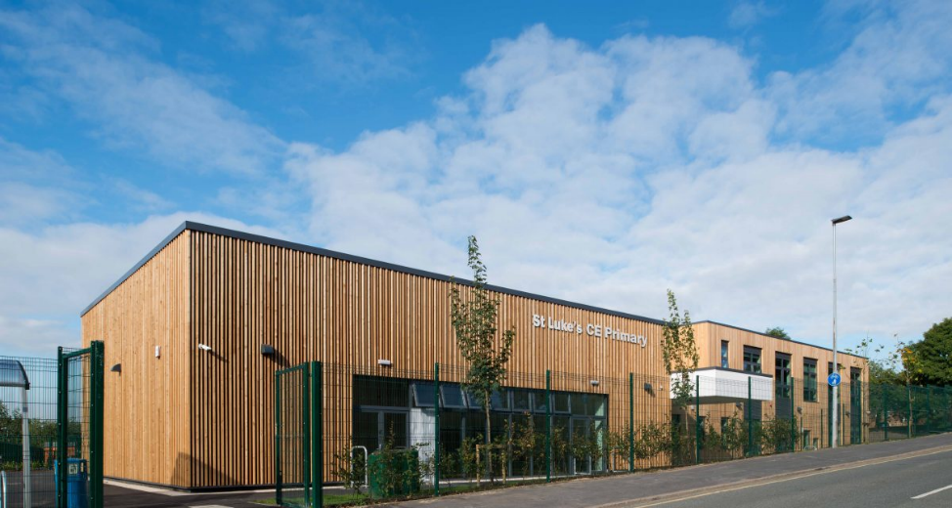



St Luke’s CE Primary School

SEND Information Report
2025 - 2026

Our School  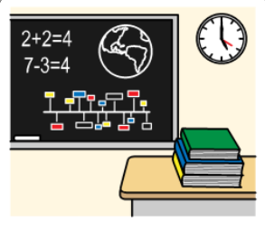 | Our School Vision  At St Luke’s CE Primary the well-being and development of each child underpins all that we do. Our aim is to develop children into confident and resilient learners, for them to develop a love of learning and to encourage them to explore opportunities to step outside of their comfort zone whilst not neglecting the need to develop wider life skills that they can use to underpin their future development.  St Luke’s CE currently has over 440 children on role  There are currently 31% of children on SEN register with a range of needs from universal to specialist.  21 children that have an EHCP (5%)
  Meet our SENCO |   The Interim SENCO is Mrs G Taylor  If you would like to contact Mrs Taylor, please call school on 01613887075 or send an email to senco@thrive-slce.com and school will aim to respond within 48 hours.
Our Inclusion Team   | At St Luke’s CE Primary School we have an experienced Inclusion Team that can support in a variety of ways.  Head of Inclusion; Mrs Taylor. Leading the Inclusion team to support pupils to access education at St Luke’s CE and make progress. Working with other professionals, staff and parents.    Pastoral Support – Mrs Whealing; Providing emotional support to children in school. Supporting with relationships, emotional regulation strategies and bereavement.    Family Support – Mrs Lomas; Supporting parents and families to understand their challenges and offer advice.

  Special Educational Needs | At St Luke’s CE Primary School we support children with a variety of differing special educational needs and we pride ourselves on being a highly inclusive school with an ethos which encourages and celebrates diversity and difference.  SEND is categorised into the following areas in the SEN code of practise 2014:
   | Cognition and Learning
   | Communication and Interaction
   | Social, Emotional and Mental Health
   | Sensory and Physical
  Our approach to teaching | We are an inclusive school. Wherever possible children are taught alongside their peers in flexible teaching groups.  Teachers adapt their high-quality teaching to cater for their pupils’ needs and plan individual timetables where necessary. When appropriate, staff are deployed to give children additional interventions in small groups outside the classroom, or to provide one-to-one support.  We use the EEF guidance ‘Five-a-day’ and embed the key principles into all our lessons.  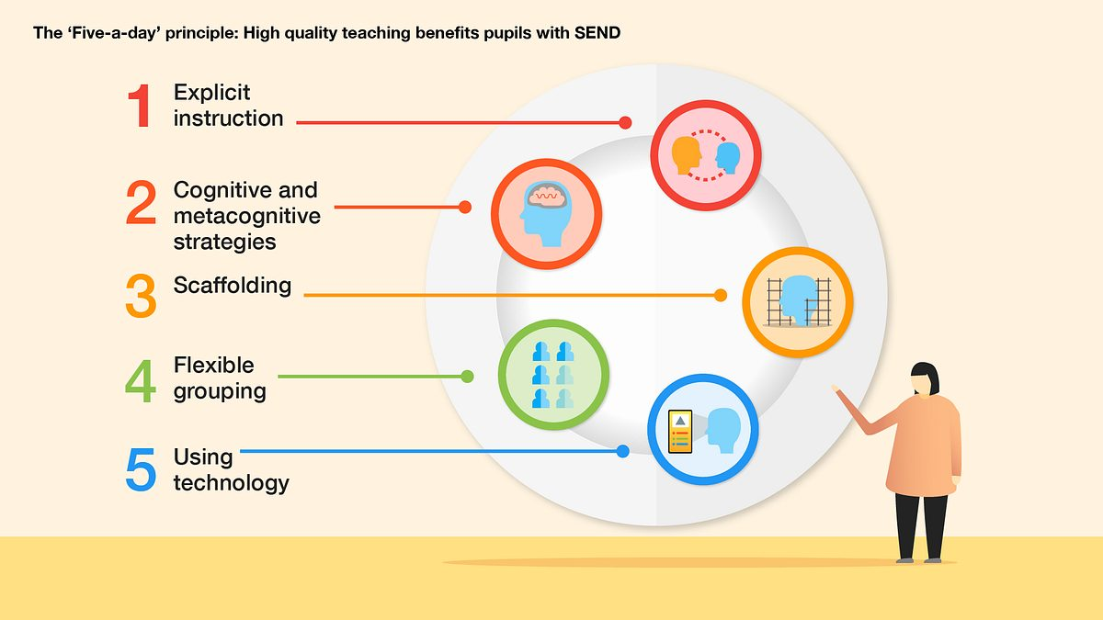
  Curriculum adaptations | We use a range of strategies across our lessons to ensure we offer an inclusive approach to learning. We also seek advice and equipment from outside agencies as and when the need arises.
   |  | 
  Visual timetables | Task boards | Peer mentoring
   |  | 
  Technology | Talk partners | Peer marking
   |  | 
  Self-assessment | Word banks | Positive behaviour
   |  | 
  Ear defenders | Timers | Explicit instruction
  Clubs and Trips | All our extra-curricular activities and school visits are available to all our children, including our before-and after-school clubs.  All children are supported to go on our trips such as day trips, residentials, and visits to church.  All children are supported to take part in sports day, school competitions, school assemblies and performances, workshops, etc.  All children are encouraged to apply for roles of responsibility in school e.g. school council, eco council, sports leaders etc.  No child is ever excluded from taking part in these activities because of their SEN or disability.
  Staff Training | At St Luke’s CE, we believe in professional development and aim to ensure all our staff have the understanding they need to enable them to support your child.  When a new member of staff joins the school, we ensure they understand the systems within school and they are given information about the children they are working with. Each class has an accessible file with SEND information to be shared with staff working with the class.  If your child needs specialist support from an outside agency, such as the Speech and Language Service (SALT), Educational Psychologist (EP), Occupational Therapist (OT) or school nurse, we will always discuss this with you first.  Some of our staff have completed training in the following areas. When staff go on a course, they have an opportunity to give feedback to the rest of the staff during staff meeting sessions.
   |  |  | 
  Play Therapy | Lego Therapy | Specific Learning Difficulties | Mental Health support
   |  |  | 
  Autism in Schools | Speech and Language | Phonics (catch-up) | De escalation
  Identifying and Assessing Need | At St Luke’s CE we work closely as a team and if staff have a concern about a child, they fill in a Worried About a Child Slip or raise it electronically on CPOMS. A member of the Inclusion Team will speak with the class teacher and the parent to gather more information. Advice and adjustments will be given to the class teacher and parent. A child will then be placed on the monitoring register for review after 6 weeks.  A Pupil Passport will be created for all adults working with the child to understand their needs. During the review period, if adjustments have not been impactful then we begin to follow the Graduated Response approach of ‘Assess, Plan, Do and Review’.  After a period of 6 – 8 weeks we will decide if a child needs to be placed on the SEND register and invite you in for a meeting, where we will share the targets your child is working on and the support they are receiving. They will receive an Individual Education Plan (IEP).  Some children may require more support than is ordinarily available and we may ask outside agencies to support us in ensuring that we are offering the best support we can.  
  Evaluating Provision | Monitoring by the class teacher.  Establishing children’s baseline before receiving interventions and reviewing the impact of interventions at regular intervals.  Asking our children if they feel the adjustment or intervention is helpful and makes a difference.  Holding termly reviews with staff for children who are on Education Health and Care Plans, SEND Support Provision Plans and those requiring specialist support. Holding annual reviews for children with Education Health Care Plans.
  Parent Consultations | At St Luke’s CE Primary School we work closely with parents and carers and recognise that they have much to contribute to our support for children with SEND.  For children who have an Education, Health and Care Plan, IEP or require specialist support (over and above what is ordinarily available) we will invite you in for 3 further meetings a year in the Autumn, Spring and Summer term with the class teacher. These meeting are used to celebrate your child’s learning, looking at the progress they have made against the targets set, create new targets and discuss next steps. A copy of this will always be sent home after the meetings.  During the year a parental questionnaire is sent out to gain views on the school and the SEND provision.
Child Consultations | Pupil’s views are very important; they have a right to be involved in decisions about their education and they are made aware of the support that surrounds them in school.  Children are fully involved and their views feed directly into all policies, procedures and daily teaching of children with SEND.  Their views are recorded on their Pupil Passports/IEPs and reviewed each term.  Pupils are given regular opportunities to:
   |  | 
  Self-assess how they are doing | Attend meetings and help decide the support needed. | Feedback and Review progress/interventions.
  Outside Agencies | We work with the following agencies to provide support for children with SEND:  CAMHS  Learning Support Service/Autism and Social Communication Team,  Salford Educational Psychology Service,  School Health Service,  Speech and Language Therapy,  Place2Be,  Primary Inclusion Team.  We will ask your permission before we arrange for any outside agencies to come in and work with your child. Once the feedback has been received we will call you in for a meeting to share the advice.
  Transition Support | Nursery & Reception  We hold a parent and carer session in the summer term for our new nursery & reception starters, providing parents with the opportunity to meet with the staff and SENCO.  We visit all new starters in their home to build relationships between home and school.  We hold two ‘stay and play’ sessions in the summer term in preparation for their September start.  If appropriate, we visit other settings that children attend to gather more information.  In Year Admission Transition  Pupils and parents will be offered a school tour and meet with a member of SLT to complete a transition information sheet.  When we are aware that pupils joining us from other settings have identified special educational needs, we arrange a meeting with the family to enable us to gain a greater understanding on the support we need to put in place, and create a bespoke transition package e.g. additional visits, meet with the teacher, adjusted timetable.  End of Year transition  When children move up a year, we provide transition sheets which include photos of the teacher, TA and classroom environment.  We hold 2 transition sessions during the summer term allowing the children to go up to their new classroom and meet their teacher.  Some children may require extra transition visits to their new classroom to help reduce their anxiety and ensure that the transition is successful and positive.  New Class teachers meet with the previous year teachers and the SENCO during the summer term to discuss the needs of the children.  Secondary Transition  We liaise very closely with our partner schools to ensure that the transition from primary school to the secondary school is as smooth as possible.  All pupils visit their new Secondary school for two taster days. Some pupils will be offered additional transition support.
  Feedback | We always love to hear from our parents, pupils and the wider community about our SEN support offer at St Luke’s CE.  We also hold coffee mornings where parents can meet up and support each other in a safe environment. During these sessions we gather parent feedback on SEN provision at St Luke’s CE, direct to training courses and support groups and offer opportunities to meet up with outside agencies.  We are a very reflective and supportive school to enable each individual to access education successfully.

